# 📊 E-Commerce Sales Dashboard (Power BI)

## 1️⃣ Project Title / Headline

**E-Commerce Sales Analysis Dashboard using Power BI**

An interactive dashboard built to analyze sales, profit, customer behavior, and product trends in an e-commerce dataset. Designed for **data-driven decision making** with drill-down features, customized visuals, and real-time insights.

## 2️⃣ Short Description / Purpose

The purpose of this project is to provide a **comprehensive view of sales performance** across states, categories, customers, and payment methods.  
It helps stakeholders identify:  
- Top-performing regions and products.  
- Profitability trends across months.  
- Customer purchasing behavior.  
- Payment mode preferences.

This project showcases the power of **Power BI + Data Modeling + DAX** for turning raw data into actionable insights.

## 3️⃣ Tech Stack

The dashboard was built using the following tools and technologies:  
- 📊 **Power BI Desktop** – Main data visualization platform for dashboard creation.  
- 📂 **Power Query** – Used for cleaning, transforming, and reshaping raw CSV data.  
- 🧠 **DAX (Data Analysis Expressions)** – Created calculated measures for KPIs like profit margin, order value, and category distribution.  
- 📝 **Data Modeling** – Relationships established between tables (Orders.csv and Sales.csv) using **Order ID** as a key to enable cross-filtering and aggregation.  
- 📁 **File Format** – .pbix for development, .png for dashboard preview.

## 4️⃣ Data Source

The dashboard is powered by **two CSV files**:

1. **Orders.csv** → Order ID, Order Date, Customer Name, State, City
2. **Sales.csv** → Order ID, Amount, Profit, Quantity, Category, Sub-Category, Payment Mode

These were cleaned and merged in Power Query before modeling in Power BI.

## 5️⃣ Features / Highlights

* **KPIs at a glance** → Total Sales, Quantity, Profit, Avg. Order Value.
* **Sales by Region** → Track sales across states and cities.
* **Category & Sub-category Analysis** → Identify profitable and underperforming product lines.
* **Customer Insights** → Top customers by revenue contribution.
* **Payment Mode Analysis** → Understand customer payment preferences (UPI, Cards, COD, etc.).
* **Profit by Month** → Monitor seasonality and monthly sales performance.
* **Interactive Filters** → Dynamic drill-down using slicers for **Quarter** and **State**.

## 6️⃣ Screenshots / Demos

### Dashboard Preview

Dashboard Screenshot

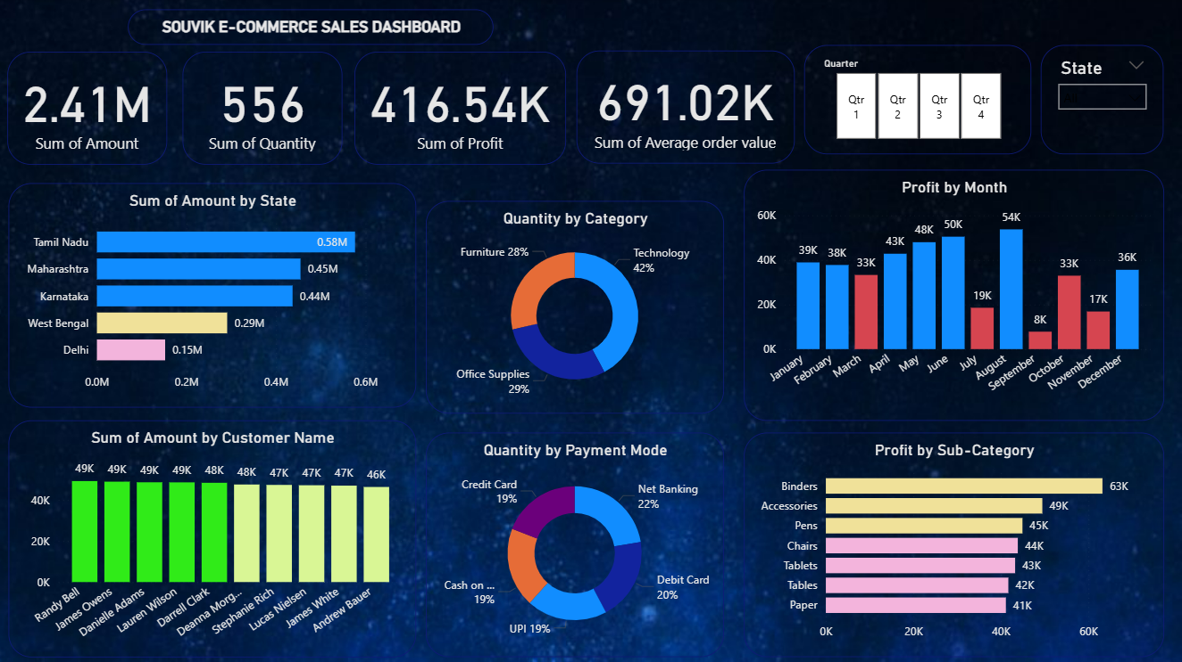Alt text: *E-Commerce Sales Dashboard displaying KPIs, sales by state, customer revenue, category breakdown, profit trends, and payment analysis.*

## 🚀 How to Use

1. Clone this repository:

* git clone https://github.com/souvik-bose7/ecommerce-sales-dashboard-powerbi.git

1. Download and install **Power BI Desktop**.
2. Open the .pbix file in Power BI Desktop.
3. Explore the interactive dashboard → apply slicers, filters, and drill-downs.
4. (Optional) Replace the sample CSV files with your own data using the same column structure.

## 📚 Future Enhancements

* Connect with **real-time sales data APIs**.
* Automate reporting using **Power BI Service**.
* Add **predictive analysis** using DAX + Machine Learning integration.

## 👨‍💻 Author

**Souvik Bose**  
- 🌐 [LinkedIn](https://www.linkedin.com/in/souvik-bose-7272ab1b3)  
- 💻 [GitHub](https://github.com/souvik-bose7)